**New Syllabus NESA Questions:**

1) D

2) A

3) A

4) C

**Past HSC Questions:**

**2018:**

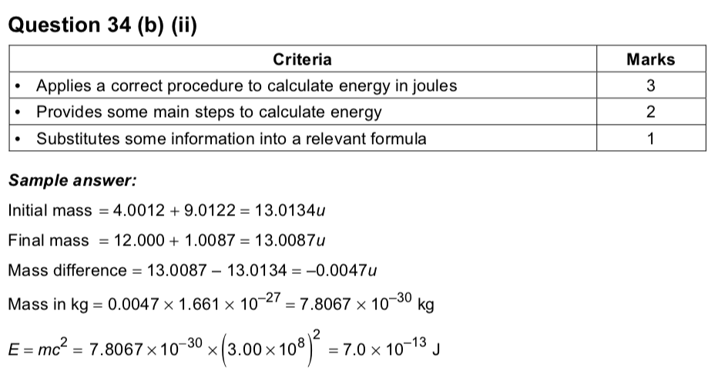

**2017:**

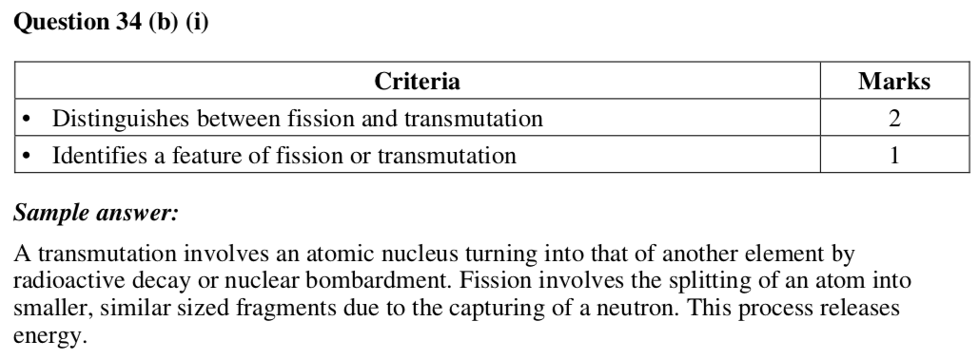

**2015:**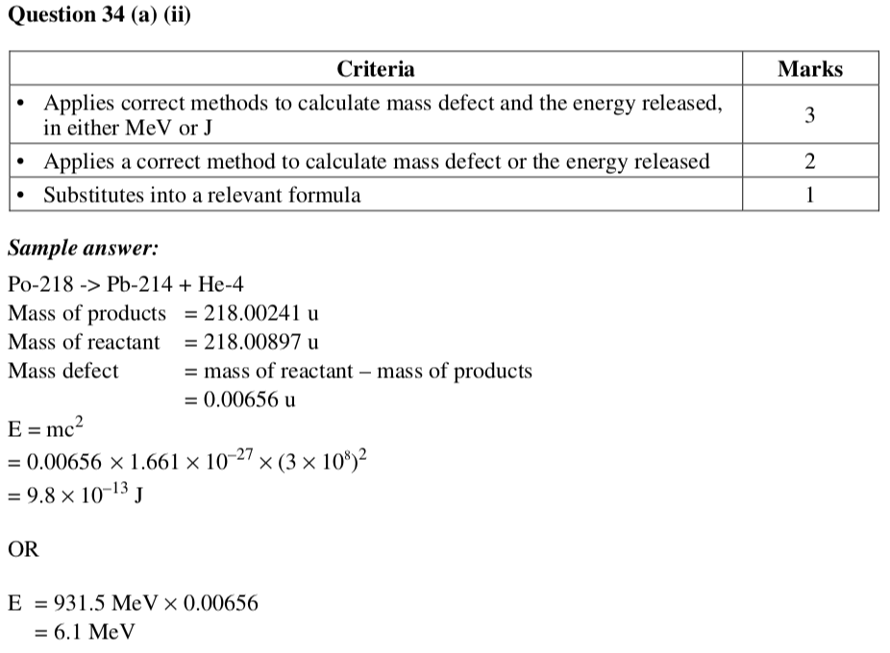

**2013:**

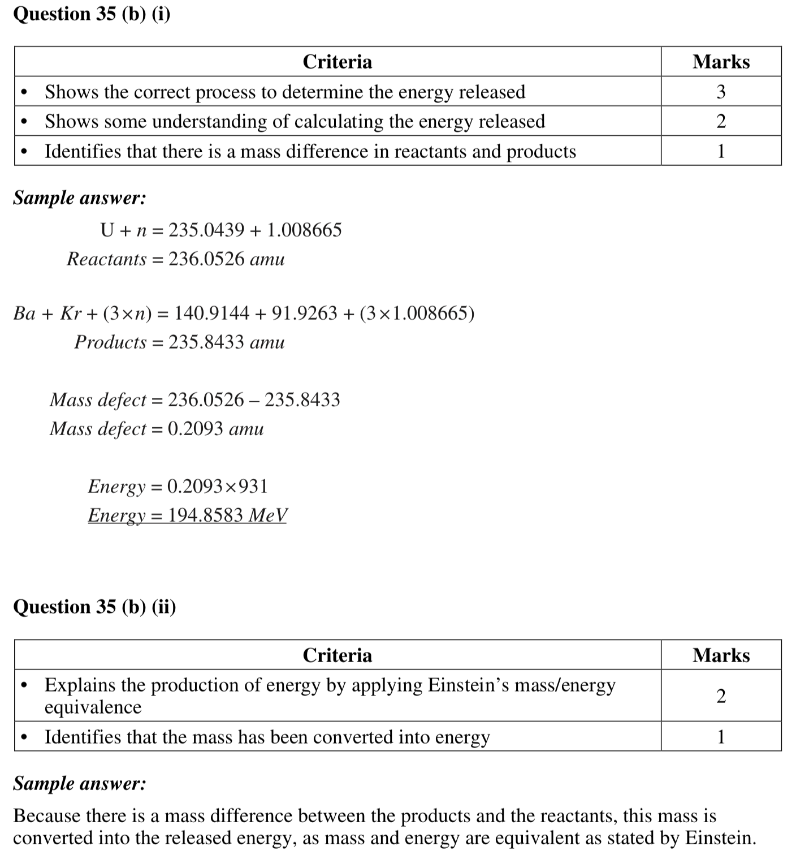



**2012:**

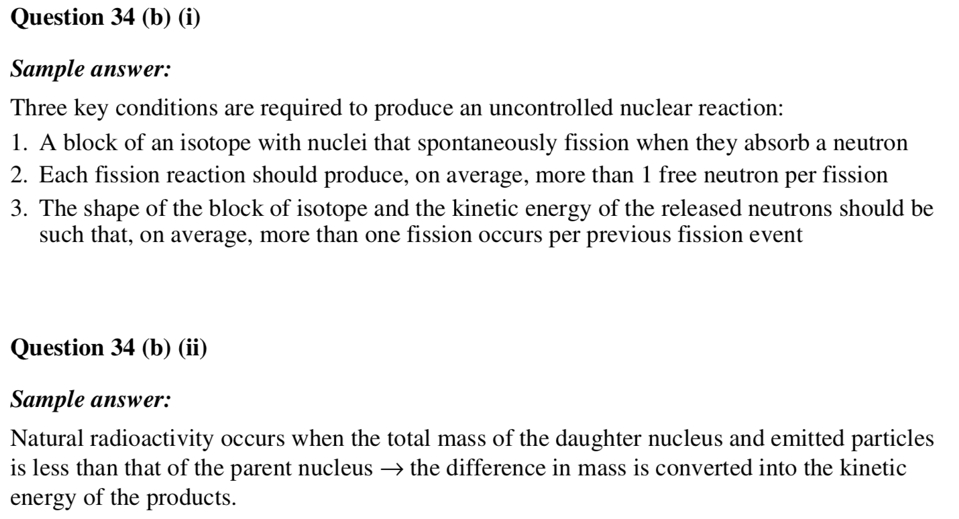

**2011:**

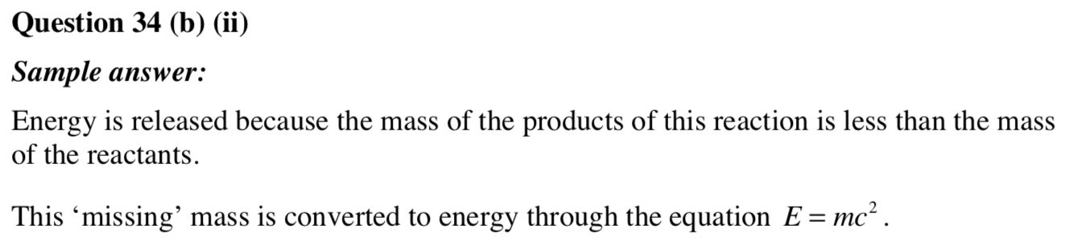

**2010:**

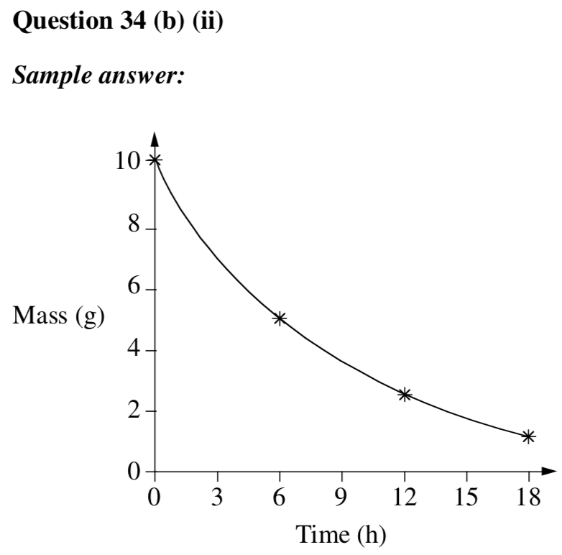

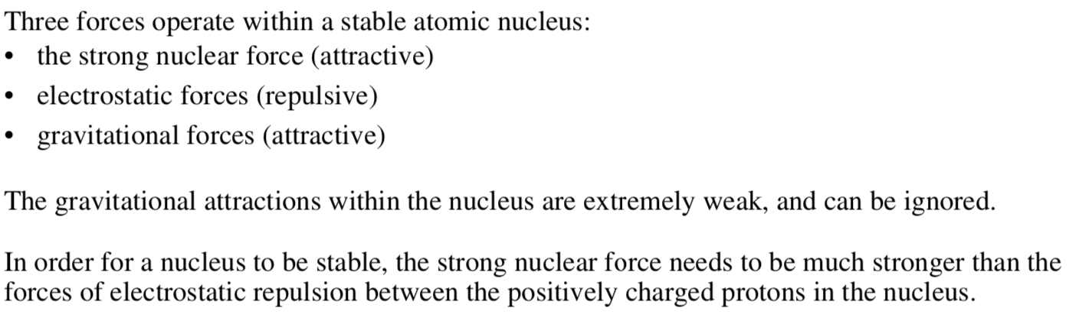

**2009:**

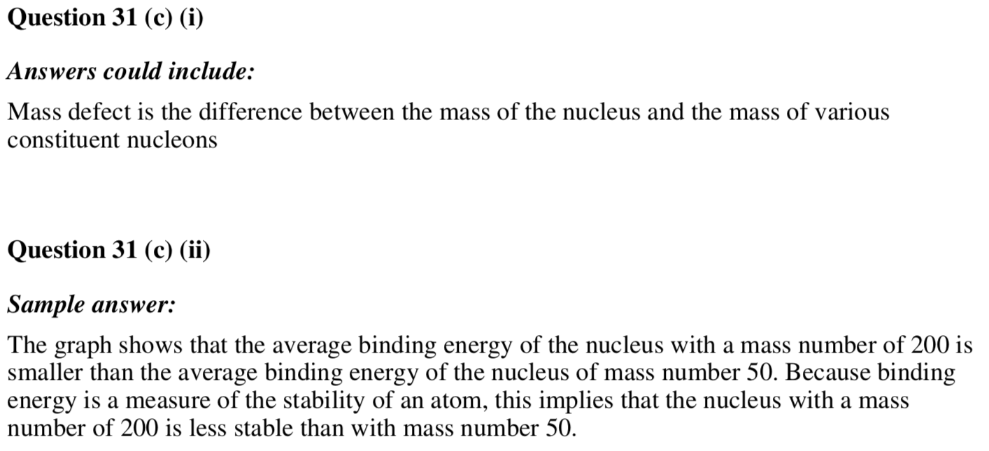

**Before 2009 there were no answers given for short answer please use a book like Excel Physics**